**Reverse Image Search**

**Our Understanding:** Building a search engine API which uses image instead of text . upload a query image and it will find the most similar images and show the result.

**Approach:** To achieve that we will use the Bfmatcher algorithm.

### **Brute Force Matcher**

Brute Force Matcher is used for matching the features of the first image i.e query image with another image (images in db)

It takes one descriptor of the first image and matches to all the descriptors of the second image and then it goes to the second descriptor of the first image and matches to all the descriptors of the second image and so on.

Images with height score will be returned as a result.

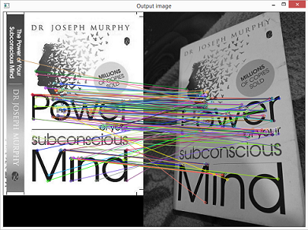

Fig : result of similarity between two images using bfmatcher algorithm

**POC :** for POC i have used the images provided by you

And applying this algorithm i have find the results which is shown below :

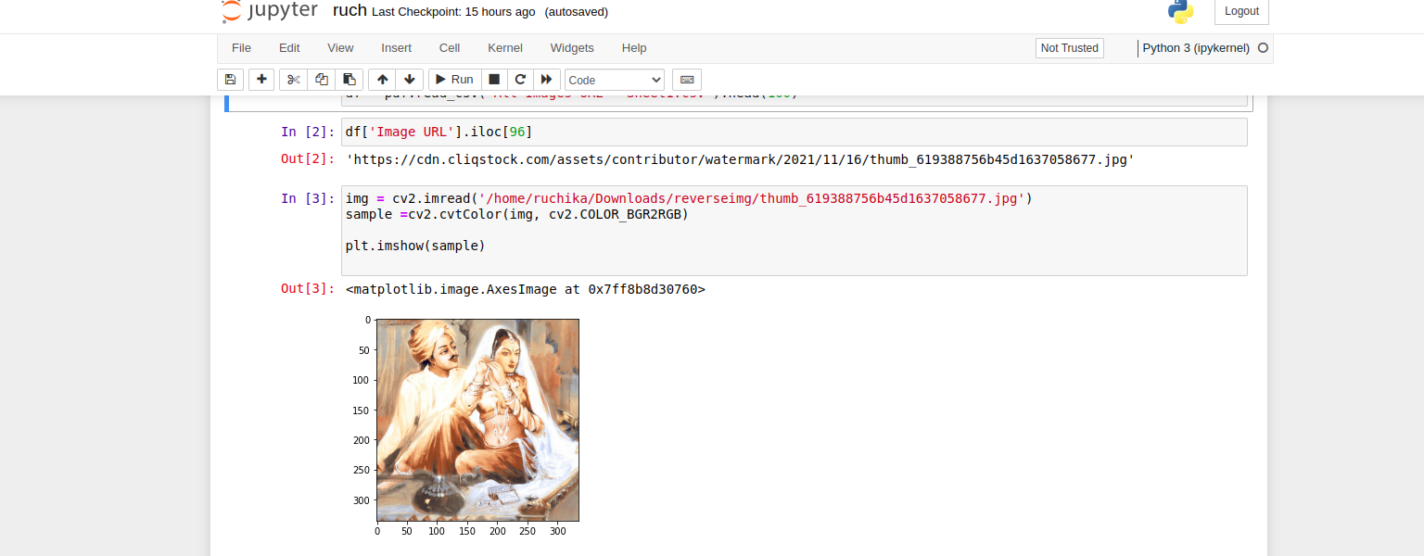

Fig: This is the query image from the data which you have provided

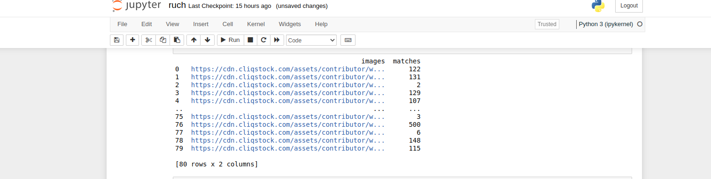

Fig: After applying the algorithm it shows the matching score between the images in df and query image.



Fig : arrange the scores in descending order so that top images can be shown.

**Result:**

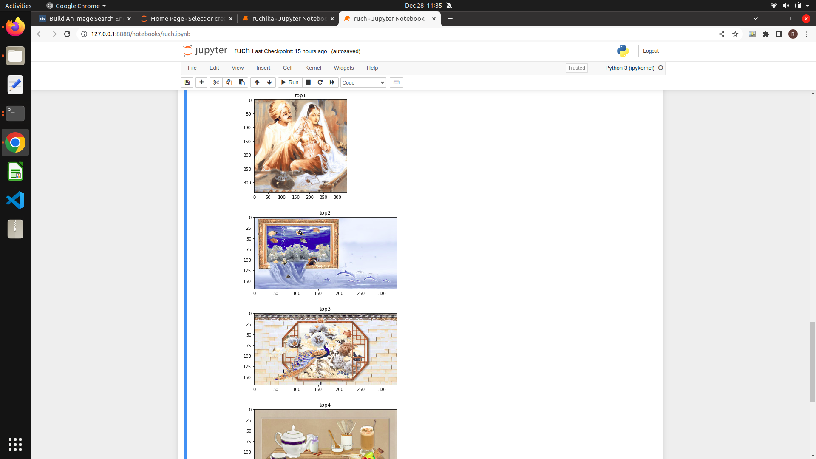

Fig : Images with highest matching score.

I have used just the top 100 images. That's why I just got one image with a height match , later I will apply a threshold only the images with height matching score will be shown.